Name ________________________

Egyptian Numbering System Webquest
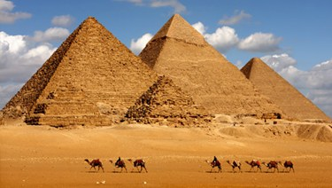
Instructions:
Use the website provided and flow the steps to complete the webquest. Good luck!

In the boxes below, draw the symbols that the Egyptians used in their numbering system:
1 | 10 | 100
1,000 | 10,000 | 100,000
1,000,000 | Great Job!!!!  Now click next

Stage 1-5 Activities:
With your partner, work on the Stage 1 – 5 activities. These activities will help you to become comfortable using Egyptian numbers. Proceed through each stage by answering the questions. Track the number of correct and incorrect answers below:

Correct Answers | Incorrect Answers

The REAL Challenge: Stage 6 – Pyramid Problems
You are required to work with your partner and complete questions 1-4, 10, 11, 13- 19. You may choose to take on numbers 5-9, 12, and 20 for extra credit. In the spaces provided below (and on the back), write the problem number, ALL of your work, and the solution to each problem! Good Luck

